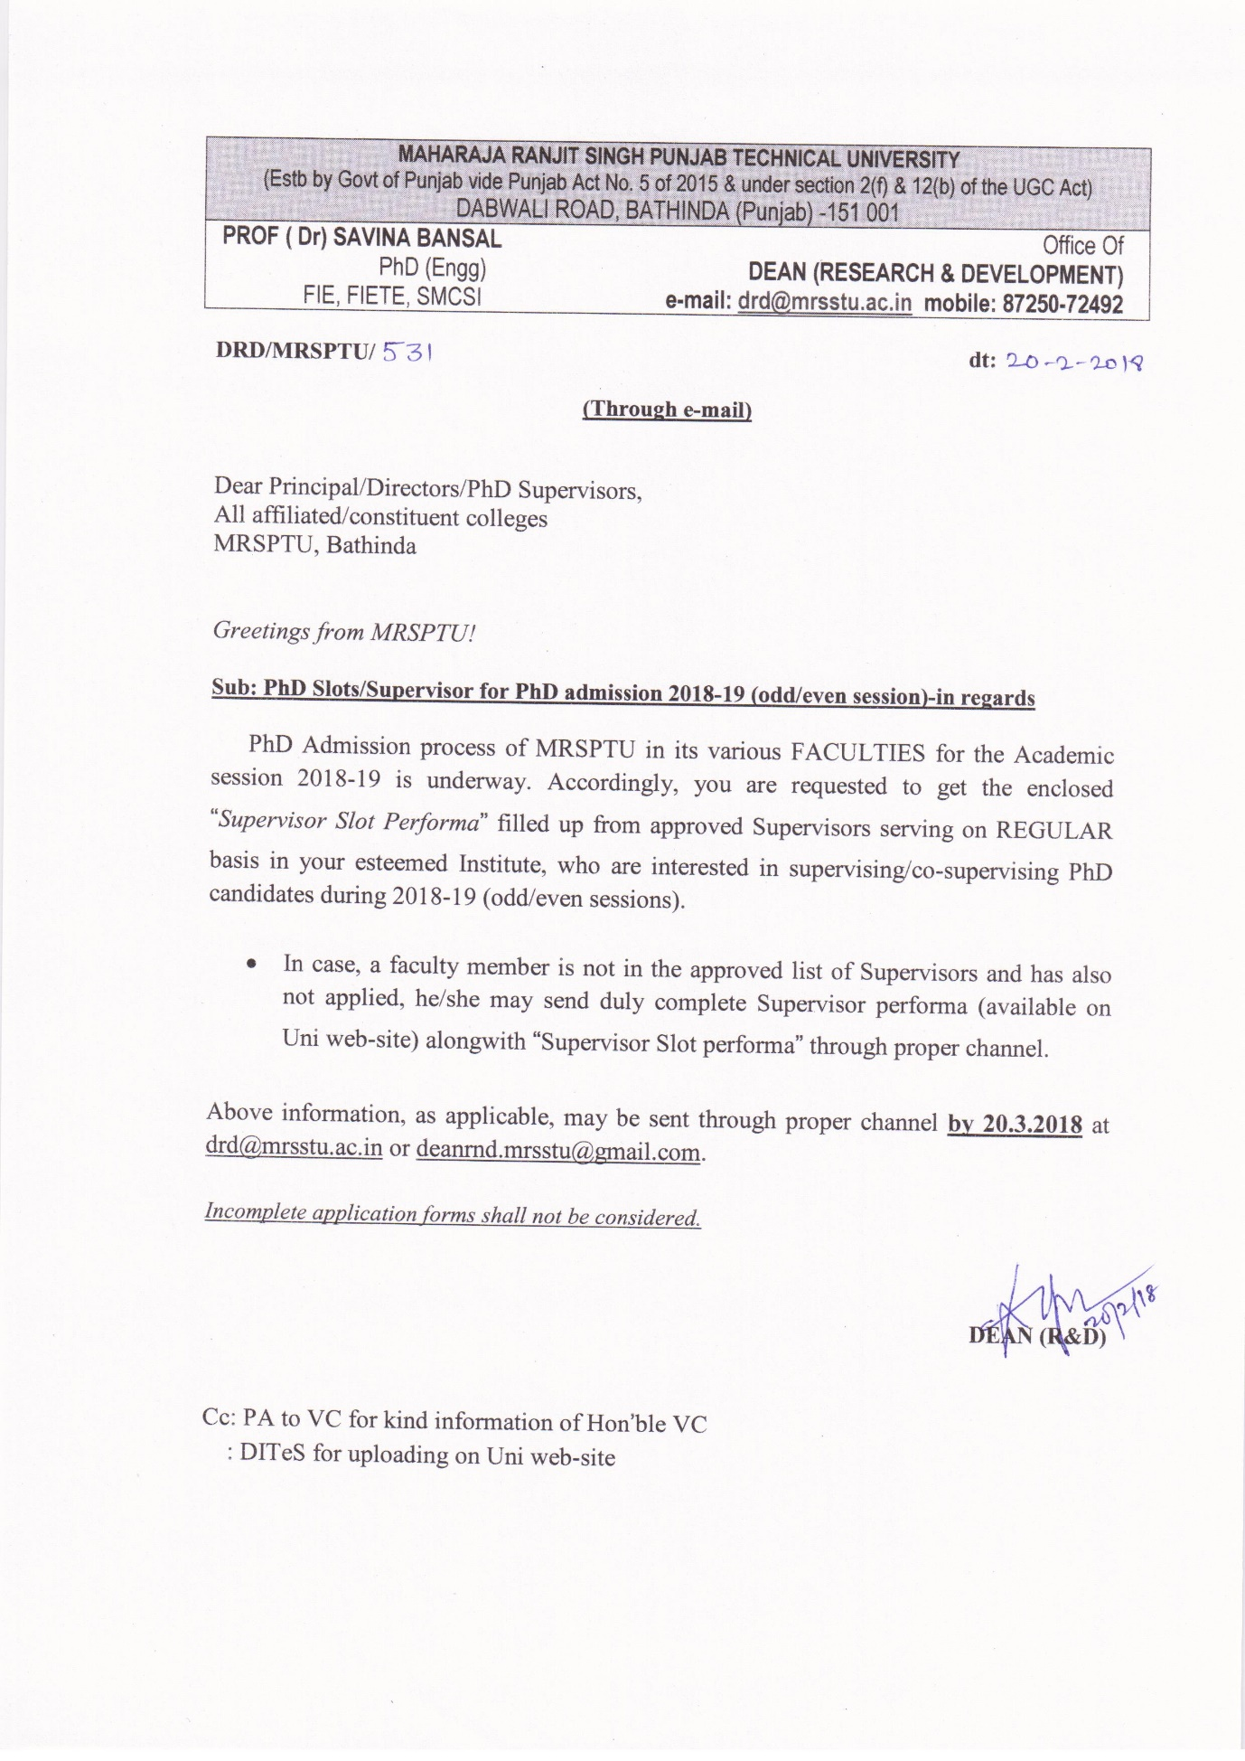
MAHARAJA RANJIT SINGH PUNJAB TECHNICAL UNIVERSITY
(Estb. By Punjab Govt vide Punjab Act No. 5 of 2015 & under section 2 (f) & 12 (b) of the UGC Act at SNo 428)
DABWALI ROAD, BATHINDA (Punjab) -151 001
Office Of
DEAN (RESEARCH & DEVELOPMENT) e-mail: drd@mrsstu.ac.in mobile: 87250-72492

PhD Supervisor Slot Performa
(to be filled by PhD supervisor desirous of supervising MRSPTU PhD candidates)

PhD Supervisor’s Slots Details for PhD Admission (2018-19)
1 | Name
2 | Designation
3 | Affiliation and mail-id/mobile no:
4 | Whether approved as MRSPTU Supervisor (If Yes, mention Supervisor–id/FACULTY/Discipline)
5 | Are you a REGULAR faculty member of the MRSPTU affiliated Institute (mention Date of Joining)
6 (i) | Total number of PhD candidates currently under your supervision / co-supervision of MRSPTU or any other University
6 (ii) | PhD Candidates already supervised/co-supervised (Thesis viva-voce defended successfully)
7 | PhD Slots demanded
8(i) | Tentative R. areas for Phd supervision (as per the slots desired)
8(ii) | Research facilities required for the above mentioned research areas (pl. specify)
8(iii) | Availability status of R facilities, as required above, in your Institute
9 | Number of R. publications in reputed Journals (attach details of best 5 R. papers in SCI/UGC listed journals)

(Signature of Supervisor)
With seal and stamp
Forwarded by Head of Institute

